## 4CS015 – Portfolio Task #4

**STUDENT NAME: Akriti Kumari Dev**

**STUDENT NUMBER: 2329584**

You will need to complete the workshop and then submit this Word file, complete with your answers, via Canvas, by the end of Semester (week 12).

For this assignment (workshop) you will show you how to navigate and create file systems from command prompt in both Windows (os) and Linux(os), also how to create a batch file to be executed in the Windows (os).

**NOTE: Please make sure you have written your command as well as the screenshot of the commands. Failure to do so will result in marks deduction.**

**Task 1 (Windows Command Line)**

1. Write a command to Create a directory "**test**".

cd desktop

mkdir test

1. Write the command to list all the directories/files inside the directory **test**

cd test

dir

1. Create a file "**hello.txt**" containing the word "Hello", inside the test directory.

echo Hello > hello.txt

1. Display the content of **hello.txt** in the command line.

type hello.txt

1. Make directory **test1** in the Desktop and copy **hello.txt** from **test** to **test1**

mkdir test1

cd test

copy hello.txt C:\Users\HP\desktop\test1

1. Now delete the file **hello.txt** in the current directory

cd ../

cd test 1

del hello.txt

1. Write a command to display your current directory.

cd

1. Now rename the file to **hello2.txt**

cd ../

cd test

rename hello.txt hello2.txt

1. Now navigate outside the directory test.

cd ../

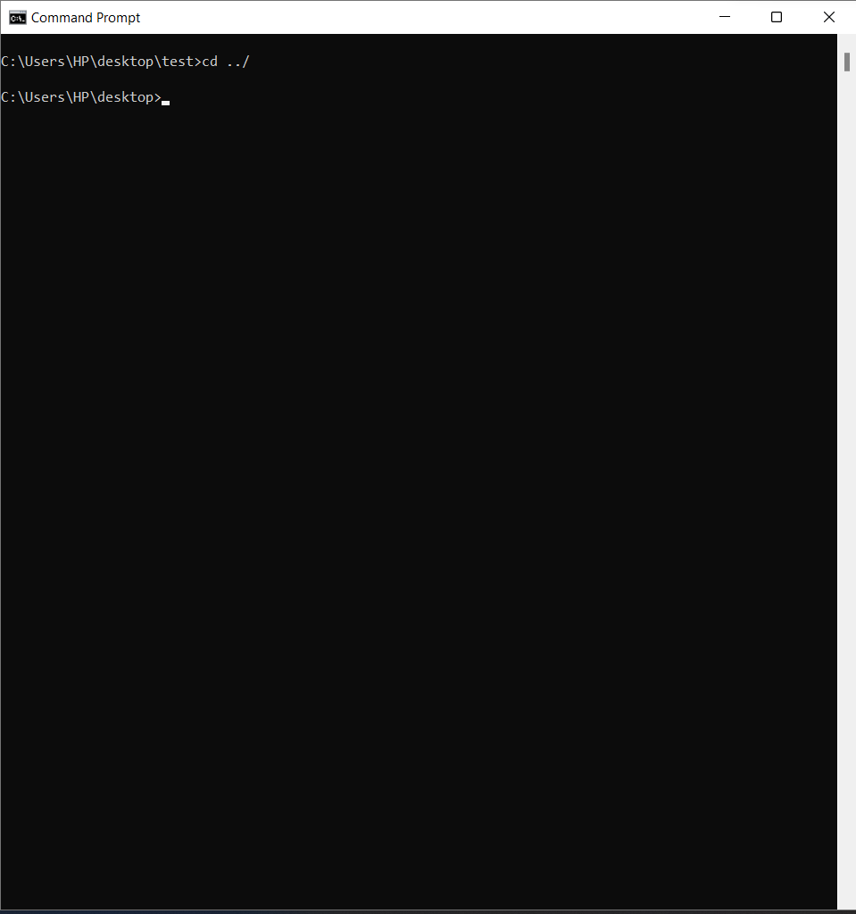

1. Write the command to print the tree structure. It should look something like this:

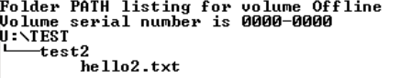

cd test

mkdir test2

move hello2.txt test2

tree /f

**Task 2**

Create the following directory structure and paste it after this picture. (15 marks):

**Note: MYMODULES must be inside <your_name> directory.**

**Make a directory with your name on the desktop and navigate to the directory before you display the following structure.**

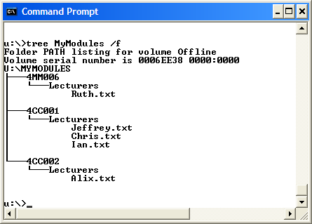

[Insert your picture here]

mkdir Akriti_Kumari_Dev

cd Akriti_Kumari_Dev

mkdir MYMODULES

cd MYMODULES

mkdir 4MM006

cd 4MM006

mkdir Lecturers

cd Lecturers

echo >Ruth.txt

cd ..

cd..

mkdir 4CC001

cd 4CC001

mkdir Lecturers

cd Lecturers

echo >Jeffrey.txt

echo >Chris.txt

echo >Ian.txt

cd ..

cd..

mkdir 4CC002

cd 4CC002

mkdir Lecturers

cd Lecturers

echo >Alix.txt

cd ..

cd ..

tree /f

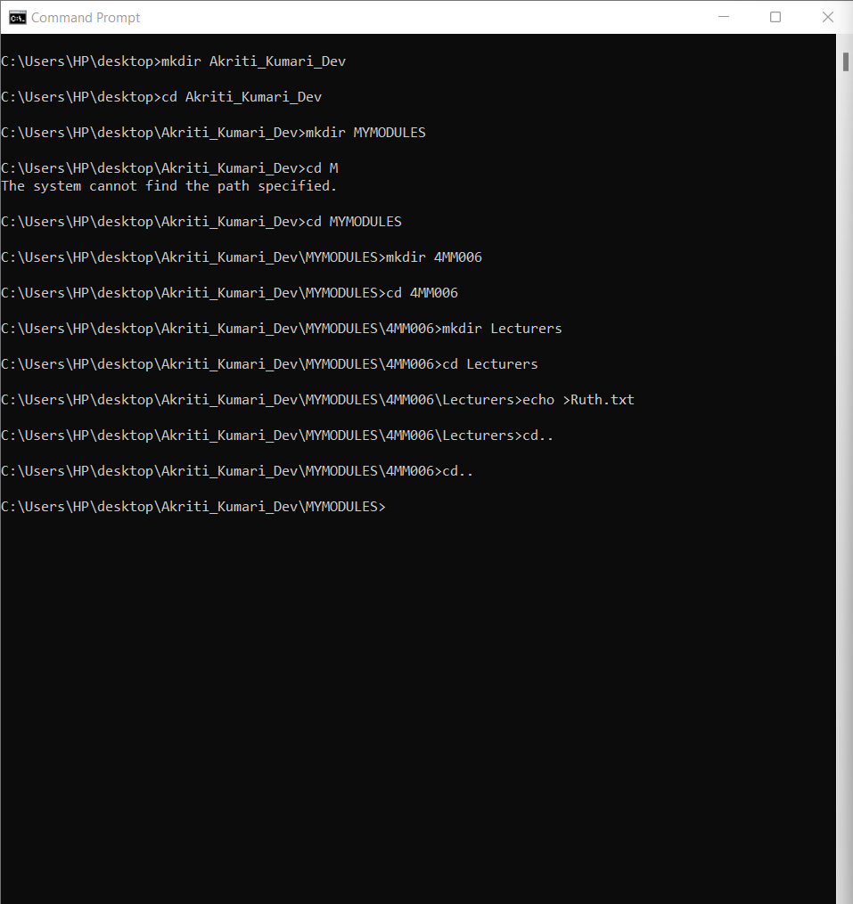

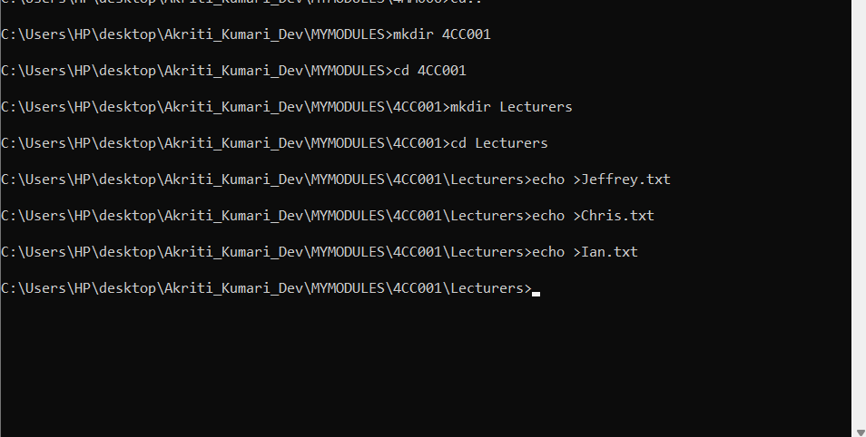

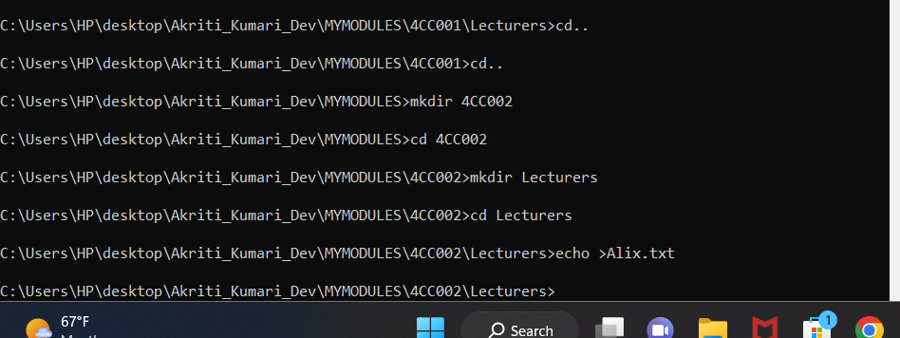

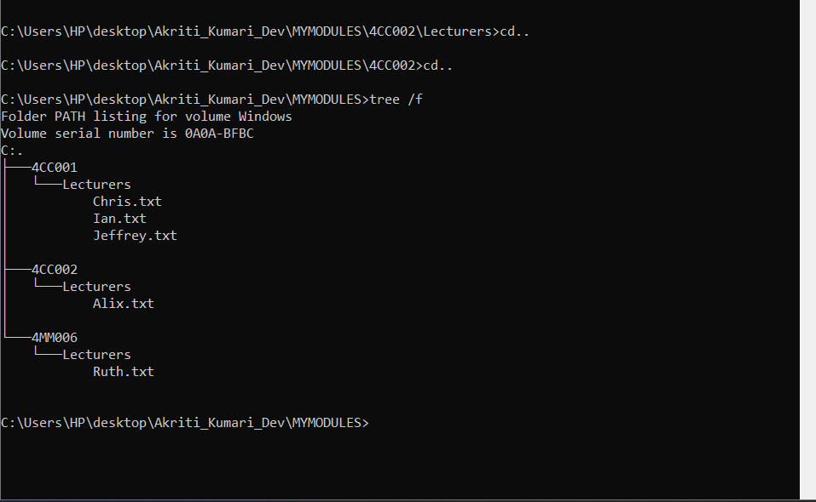

**Task 3(Linux terminal)** (10 marks)

Now, Boot into Linux operating system in virtualbox or Windows-SubSystem for LInux(On Windows)

1. Write a command to Create a directory "**test**"

mkdir test

1. Write the command to list all the directories/files inside the directory **test**

cd test

ls

1. Create a file "**hello.txt**" containing the word "Hello", inside the test directory.

echo ‘Hello’ >hello.txt

1. Display the content of **hello.txt** in the command line.

Cat hello.txt

1. Make directory **test1** in the Desktop and copy **hello.txt** from **test** to **test1**

mkdir desktop

cd desktop

mkdir test1

cd ..

cp hello.txt ~/test/desktop/test1

1. Now delete the file **hello.txt** in the current directory

cd ../test1

rm hello.txt

1. Write a command to display your current directory.

pwd

1. Now rename the file to **hello2.txt**

mv hello.txt hello2.txt

1. Now navigate outside the directory test.

cd ../

1. Write the command to print the tree structure.

tree test test1

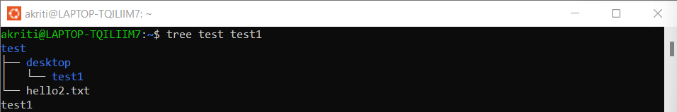

**Task 4**

Create the following directory structure (identical to the one that you created in Windows Command Prompt):

**Note: MYMODULES must be inside <your_name> directory.**

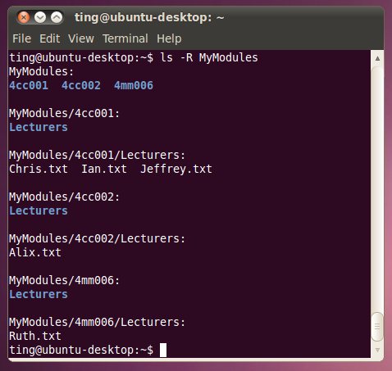

and insert it below (15 marks):

[Insert your picture here]

mkdir Akriti_Kumari_Dev

cd Akriti_Kumari_Dev

mkdir MYMODULES

cd MYMODULES

mkdir 4cc001

mkdir 4cc002

mkdir 4mm006

cd 4cc001

mkdir Lecturers

cd Lecturers

touch Chris.txt

touch Ian.txt

touch Jeffrey.txt

cd ../..

cd 4cc002

mkdir Lecturers

cd Lecturers

touch Alix.txt

cd ../..

cd 4mm006

mkdir Lecturers

cd Lecturers

touch Ruth.txt

cd ../..

cd ..

ls -R

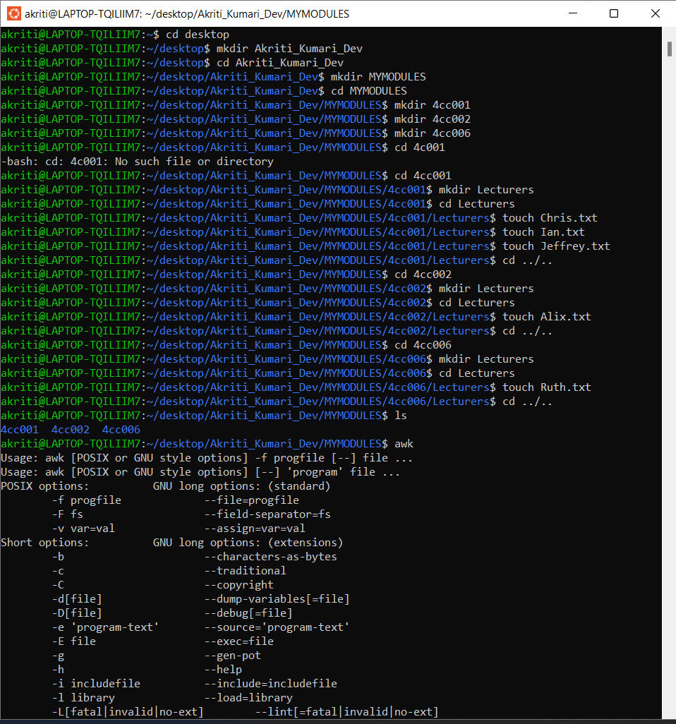

**Task 5**

**Batch file material (50 marks in total)**

Create a batch file (windows) **YourNumber.bat** from notepad (or your preferred text editor). Create this program on your home drive (or portable drive – USB) ready for execution.

The batch file should create a directory structure similar to the one create for the first section of this assignment but the directory entries should be provided from an input request from the batch file itself.

You should be able to create a root directory and directory structure and populate it if required. The batch file program will ask for names (**input directory names and file names**) to be used and have some form of **error checking** (empty – incorrect character, length, etc.) You can add other features such as being able to edit the new structure from within the batch file program (**find and change a directory name**).

Run batch file from windows prompt: YourNumber.bat <enter>

[Insert your picture(s) here] – Directory structure created / menu of batch file (inputs and output when batch file is executed) (10 marks)

[Insert your text here] – batch file listing (script)(40 marks)

@echo off

:InputDirectoryName

set /p dirname=Enter the root directory name:

if "%dirname%" == "" (

echo Error: Empty directory name

goto InputDirectoryName

)

if exist %dirname% (

echo Error: Directory already exists

goto InputDirectoryName

)

mkdir %dirname%

cd %dirname%

:InputSubDirectoryName

set /p subdirname=Enter a subdirectory name (or type exit to stop):

if "%subdirname%" == "" (

echo Error: Empty directory name

goto InputSubDirectoryName

)

if "%subdirname%" == "exit" (

goto End

)

mkdir %subdirname%

cd %subdirname%

:InputFileName

set /p filename=Enter a file name (or type exit to stop):

if "%filename%" == "" (

echo Error: Empty file name

goto InputFileName

)

if "%filename%" == "exit" (

cd ..

goto InputSubDirectoryName

)

echo This is a sample file > %filename%.txt

goto InputFileName

:rename

echo Enter current name:

set /p n3=

echo Enter new name:

set /p n4=

rename "%n3%" "%n4%"

pause

:End

echo Directory structure created successfully.

tree /f

pause

exit